

New Swim Parent Handbook & Information
2025-2026

Table of Contents
Introduction……………………………………………………………………………………………………..3
Welcome to the ODAC 2025–2026 Swim Year…………………………………………………..3
ODAC Core Values…………………………………………………………………………………………….4
ODAC Parent Commitments……………………………………………………………………………..4
ODAC Athlete Commitments…………………………………………………………………………….4
ODAC Pledge…………………………………………………………………………………………………….4
ODAC Grievance Process……………………………………………….………………………..………..4
ODAC Practice Group Equipment Expectations…………………..………………………….5-7
Swim Meets 101……………………………………………………………………………………………….8
Meet Commitment …………………………………………………………………………………………..8
What Happens on Meet Day……………………………………………………………………………..8
Meets – Frequently Asked Questions…………………………………………………………….…..9
ODAC's Meet Culture………………………………………………………………………………………...9
Tips for ODAC Parents…………………………………………………………………………………….….9
Swim Meet Sign-up Information……………………………………………………………….…10-13
Meet Announcement & Specifics………………………………………………………………….….13
Psych/Timeline/Warmups…………………………………………………………………………….….14
ODAC Meet Uniform………………………………………………………………………………………..14
How to sign up to volunteer on the ODAC website………………………………………14-15
Volunteering for ODAC Hosted Meets………………………………………………………….…..16
Recommended Swimming Apps………………………………………………………………….16-17
Understanding USA Swimming Time Standards………………………………………………..17
USA Swimming time standards defined……………………………………………………….17-18
Why Time Standards Matter at ODAC……………………………………………………………....19
Real Talk: Standards Are Guidelines — Not Labels…………………………………………....19
Coach's Advice for Parents………………………………………………………………………………..19
Where to Find Time Standards………………………………………………………………………….19
ODAC Communication & Support Guide……………………………………………………………20
Where to Find Information………………………………………………………………………………..20
Who to Contact………………………………………………………………………………………………….20
ODAC Communication Expectations………………………………………………………..…………21
ODAC Frequently Asked Questions (FAQ)……………………………………………….……..21-22

Introduction
This handbook is a good resource for families new to swimming or for families who want a refresher. We will cover information ranging from how to sign your swimmer up for a meet, to timing and volunteering information as well as many other meet related questions.
Welcome to the ODAC 2025–2026 Swim Year
Dear ODAC Families,
Welcome to Old Dominion Aquatic Club—a parent-powered, coach-driven, year-round program serving swimmers across Tidewater. Since our origins in 1978, when a small band of families transformed a 15-member group into what became ODAC, we’ve been built on tradition, volunteerism, and competitive excellence. That legacy still drives us—on deck, in the stands, and in the community.
We’re proud to be a Virginia Swimming club that develops athletes from first meet to championship stages, with training and registration centralized through our website and SportsEngine platform. You’ll find practice and meet information, sponsor links, and site contacts on our homepage—and yes, we’re active on Facebook and Instagram so families can follow team news, highlights, and reminders throughout the season.
ODAC’s culture is more than fast swims—it’s family. Our long-standing Bingo program is a major engine for affordability and team cohesion, and it only works because ODAC families show up. The Bingo pages list teams, work nights, and updates; the program is also registered with Virginia’s charitable gaming oversight—proof that we run it the right way, the ODAC way.
Our athletes continue to raise the bar. Over the years, ODAC swimmers have advanced from age-group success to high-level postseason competition, and the club has been recognized multiple times by USA Swimming’s Club Excellence program—markers of sustained progress that reflect your kids’ work ethic and our coaches’ standards. Keep an eye on social posts and team emails for meet recaps and milestones as the season unfolds.
This New Family Handbook is your playbook. Inside, you’ll find: how to declare for meets in SportsEngine, what to expect on meet day, required gear by practice group (ODAC is proudly a TYR program), communication channels and office hours, volunteer expectations (including Bingo), motivational time standards and goal-setting tools, plus a glossary and FAQ to cut through the swim-speak. Our aim is simple: minimize confusion, accelerate onboarding, and keep focus on what matters—consistent training, healthy habits, and team-first racing.
Thank you for choosing ODAC. Bring the energy, respect the process, and be ready to compete. If we all do our jobs—athletes, parents, coaches, and volunteers—this season won’t just be fast; it’ll be ODAC strong.
— Old Dominion Aquatic Club Leadership & Coaching Staff
Core Values
🏛️ Tradition: Rooted in over 40 years of excellence and team spirit.
🤝 Community: Parent-powered and athlete-focused—we rise together.
💪 Discipline: Show up prepared. Train with focus. Honor your effort.
🏆 Sportsmanship: Respect teammates, competitors, coaches, and officials.
🔁 Progress Over Perfection: Consistent growth, not instant results.
🚫 Parent Conduct: Support from the stands. Let coaches coach.
Swimmer Commitments
- Arrive on time and prepared with proper gear
- Focus during practice and meets
- Be respectful on deck and online
- Represent ODAC with pride and humility
Parent Commitments
- Volunteer as part of the ODAC Point System
- Communicate appropriately with coaches
- Refrain from coaching your swimmer during practice or competition
- Promote team spirit and positive conduct on social media
Our Shared Pledge
We commit to upholding ODAC’s values of dedication, sportsmanship, and community—both in and out of the pool. Together, we build champions in swimming and in life.
Grievance Process
If you have an issue, the first person to talk to is your child’s Primary Group Coach. If they are unable to help, the next person to speak to is the Head Coach, and finally the board.

ODAC Practice Group Equipment Expectations (All Sites)
Expectations (applies to every swimmer)
- Competition gear: ODAC team suit and team cap (TYR) are required at all meets. Parent-purchased.
- Supplier: TYR is ODAC’s exclusive supplier for suits and equipment. Use the team portal for ordering. (Team Code = ODAC25)
- Bring to every practice: practice suit, goggles (plus a spare), water bottle, and the full gear list for your group (below).
- Label everything. If it isn’t labeled, it’s not yours for long
Super Squad Yellow (Evening & Afternoon)
Expected Equipment:
- TYR Fins
- TYR Mesh Bag
- TYR Jr. Kick Board

Super Squad Blue (Honey Bee & Great Bridge; includes Afternoon Blue at GB)
Expected equipment:
- TYR Fins
- TYR Mesh Bag
- TYR Jr. Kick Board

9–10 Group (Honey Bee & Great Bridge; includes Afternoon 9–10 at GB)
Expected equipment:
- TYR Hydroblade Fins
- TYR Mesh Bag
- TYR Jr. Kick Board

- TYR Catalyst or Strokemaker Paddles
- TYR Snorkel (front-mount)
- TYR Jr. Pull Buoy

11–12 Group (Honey Bee & Great Bridge)
Expected equipment:
- TYR Hydroblade Fins
- TYR Mesh Bag
- TYR Jr. Kick Board
- TYR Catalyst or Strokemaker Paddles
- TYR Snorkel
- TYR Jr. Pull Buoy

Senior 3 (Honey Bee & Great Bridge)
Expected equipment:
- TYR Hydroblade Fins
- TYR Mesh Bag
- TYR Jr. Kick Board
- TYR Catalyst or Strokemaker Paddles
- TYR Snorkel
- TYR Jr. Pull Buoy

Senior 2 (Honey Bee)
Expected equipment:
- TYR Hydroblade Fins
- TYR Mesh Bag
- TYR Jr. Kick Board
- TYR Catalyst or Strokemaker Paddles
- TYR Snorkel
- TYR Jr. Pull Buoy
- Parachute/Mitts/Boots

Senior 1 (Great Bridge)
Expected equipment:
- TYR Hydroblade Fins
- TYR Mesh Bag
- TYR Jr. Kick Board
- TYR Catalyst Paddles
- TYR Snorkel
- TYR Jr. Pull Buoy
- Nose Plug
- TYR Training Strap
- Finis Sculling Paddles
- Mesh/Polyester Practice Suit

Swim Meets 101 – ODAC Parent & Swimmer Guide
Swim meets are where training turns into results. At ODAC, meet participation is expected and essential. This guide will help you understand how swim meets work, what to expect, and what your role is as a parent and swimmer.
ODAC Meet Commitment
- Swimmers are expected to compete in meets regularly throughout the season.
- Recommended frequency: 1–2 meets per month depending on practice group.
- Participation in ODAC-hosted meets is strongly encouraged.
- Championship meet attendance is a key seasonal goal.
What Happens on Meet Day
Arrival & Warmups:
- Arrive 20 minutes before warmups begin.
- Coaches lead structured warmups; attendance is expected.
- Absences must be communicated to the coach in advance.
During the Meet:
- Meets are split into sessions (morning/afternoon/evening).
- Swimmers race in 2–5 events per session, including relays.
- Events are seeded by time, not lane.
- Heats are determined by entry time, regardless of age within the event.
Between Events:
- Rest, rehydrate, and stay warm.
- Swimmers check in with coaches before & after each race for feedback.
Relays:
- Participation in relays is a team responsibility.
- Swimmers are expected to stay until all relays are completed.

Meets – Frequently Asked Questions
How long is a swim meet?
Most sessions last 3–4 hours. All-day meets (prelims/finals) may run longer. Plan ahead and bring supplies to stay comfortable.
Can we leave when our swimmer is done?
Not if your swimmer is in a relay. Always confirm with your coach before leaving.
Do I have to time or volunteer?
Yes. ODAC is a volunteer-run club. Families will be asked to sign up for roles like timing or hospitality. These assignments are posted before each meet.

ODAC's Meet Culture
Swim meets are not just about best times—they’re about building resilience, confidence, and team unity.
Our swimmers are expected to:
- Compete with intensity and sportsmanship
- Cheer for teammates
- Handle both success and disappointment with maturity
- Focus on process, not just placement or medals
Tips for ODAC Parents
- Let coaches coach — avoid giving technical feedback during meets.
- Celebrate effort and improvement, not just time drops.
- Stay flexible — swim meet schedules are always fluid.
- Promote a positive experience for your swimmer and others.

Swim Meet Sign-up Information
Swim Meet Information – Finding upcoming swim meets and events on ODAC website
- Sign in to ODAC’s website.
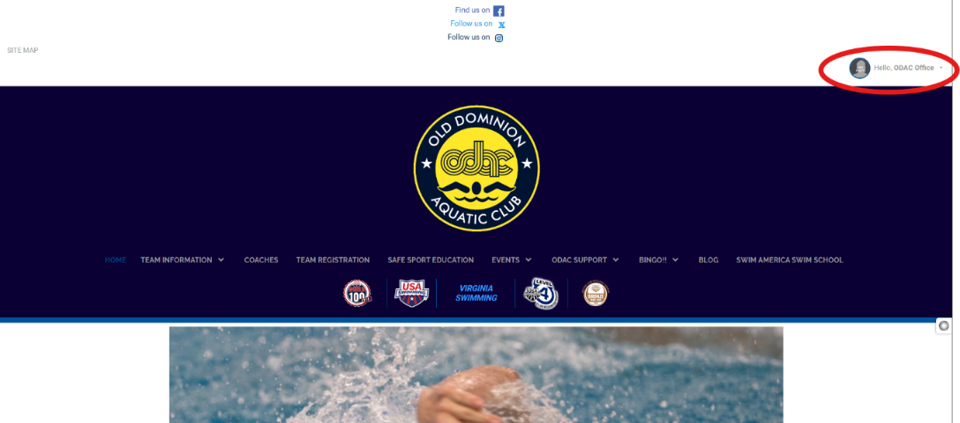
- Find “Upcoming Events” on the homepage.
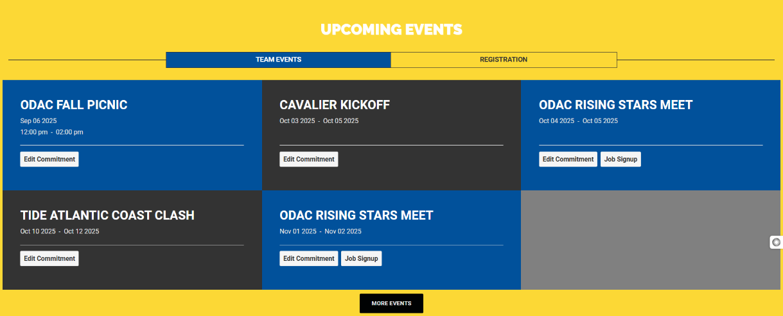
- Click directly on the event name to see specific information about the event.
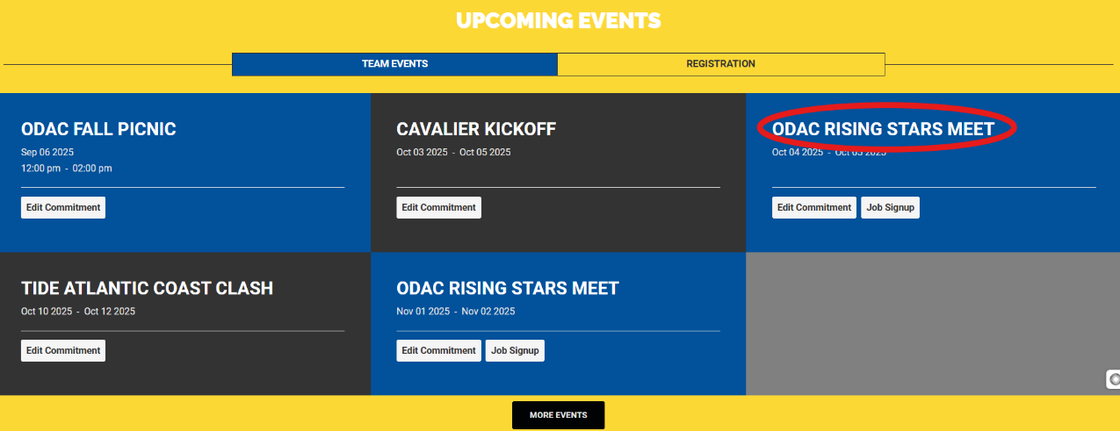
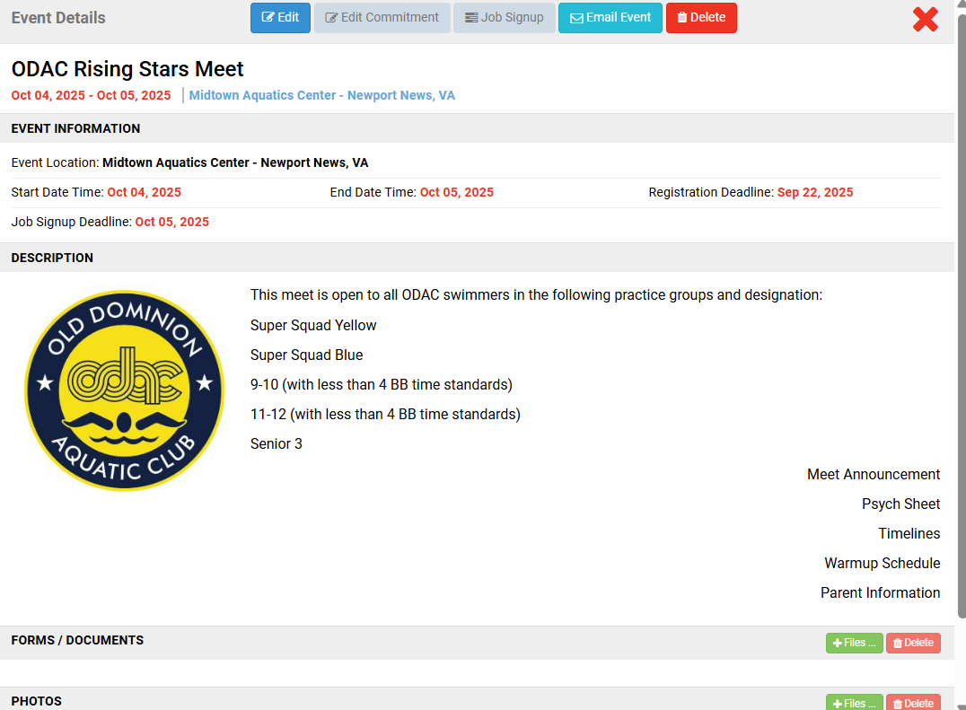
- Click your desired event’s Edit Commitment button.
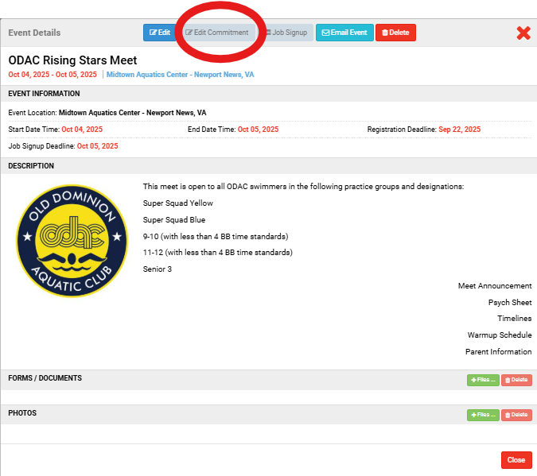
- Click the name of the athlete whom you want to attend.
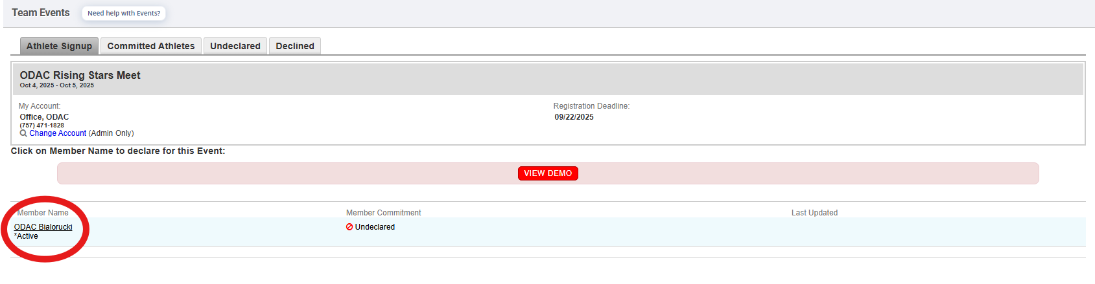
- Click the Declaration dropdown and click Yes, please sign [Name] up for this event (or No, thanks, [Name] will NOT attend this event, enter any Notes, and then click Save Changes).
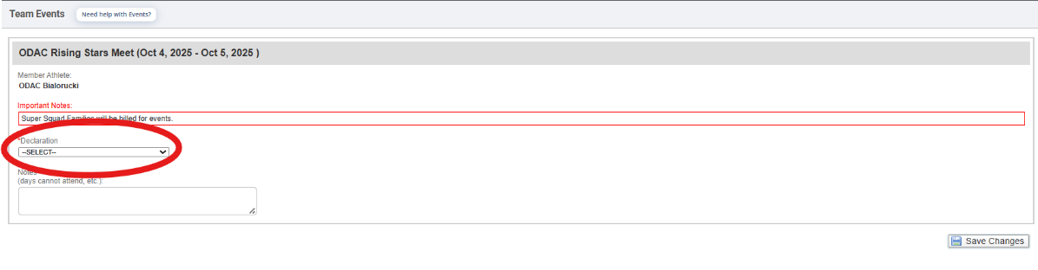
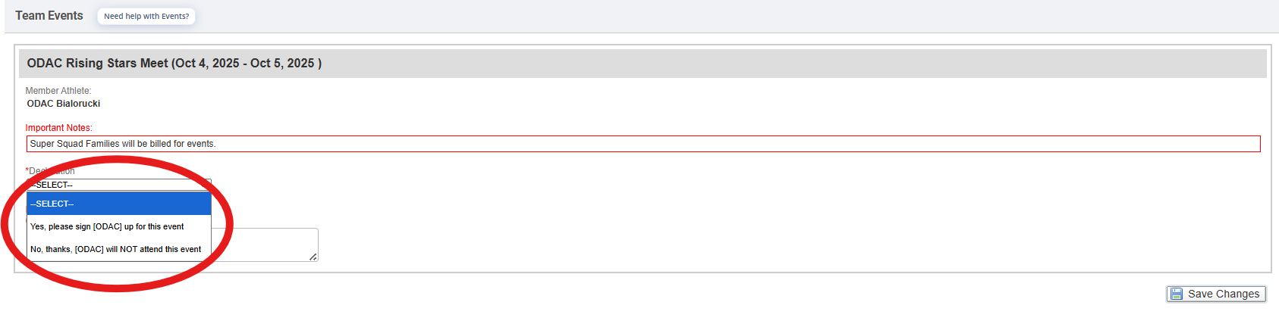
- If applicable, enter any Notes you want the coach to see.
- If a team admin has allowed you to select events, check the boxes of the events you want your athlete to enter.
  - Red times indicate your athlete is not qualified to enter those events.
  - Events you choose are subject to coach approval.
- Otherwise, select which days and sessions your athlete will attend, and a coach will then pick which events your athlete will enter.
  - You may click a day/session button to see scheduled events.
- When finished, click Save Changes.
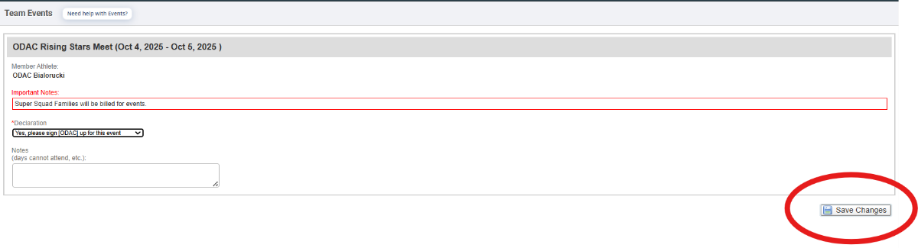
- Repeat for all other athletes you may have.

Meet Announcement & Specifics
The meet announcement PDF for a meet contains the following important information. Please read the meet announcement.
- Meet location
- Days and Sessions for the meet (i.e. which sessions does an 11-year-old swim, etc)
- Order of events
- Qualifying times (if any) for the meet
- Prelims/Finals information
  - Tips:
  - The timeline document is added as a meet document once it has been created. This document tells you when an event will start and when the session will end.
  - A psych sheet lists swimmers in order from fastest to slowest. Not all meets will have this posted.
  - Prelims/Finals are meets where there is a morning/afternoon session and an evening session. If a swimmer finishes in the top 16 (read meet announcement for number of spots), then they will return in the evening to swim the event(s) again.
  - Timed Finals are when all heats of a particular event are swum once during a meet. Seeding for these heats are determined by the meet host. They may be swum slowest to fastest or fastest to slowest. The final placement of the swimmers is determined once all the heats are swum and the times are ranked.
  - Swim meet information can also be found on the Virginia Swimming website: www.virginiaswimming.org

How to find Psych/Timeline/Warmups and ODAC uniform information
Once the Psych Sheet, Timeline, and Warmup documents are created and sent by host teams, they will be uploaded to the meet and can be found on the meet information page shown above.
An email will be sent out from the ODAC office to all families attending a couple of days before the meet with the following information:
- Psych Sheet (if available)
- Timelines
- Warmup Schedule
Parent Information: When to arrive for warmups, warmup start times/session, meet start time/session, which color shirt to wear on each corresponding day, etc.

Shirts, Caps, & Suits
ODAC t-shirts are ordered three times per year. The initial order is placed in September, with another smaller order being placed in December/January, and the third order being placed in March/April. As orders get smaller, the price per piece increases. Caps are available for purchase for $12.00 each. Traditionally, shirts are worn in the following order:
- Thursday (White Two-sided)
- Friday: Gray
- Saturday: Yellow
- Sunday: White (Retro Logo)
ODAC Team suits and caps are required for all members that compete for ODAC at meets in any capacity.

How to sign up to volunteer on the ODAC website
- Note: You are only asked to volunteer if you have a swimmer at that meet, unless you need family volunteering points and are willing to complete volunteering tasks.
- Verify the sessions and times, order of events from the Meet Announcement as described earlier
- Find the meet and the corresponding events your swimmer is entered to swim
- Log into the ODAC website (www.swimodac.com) > Scroll down to Upcoming Events > Find correct meet > Click on Job Signup > Click on box next to the session you want to volunteer and then click on Signup button > Enter optional contact info and hit “Sign Up”
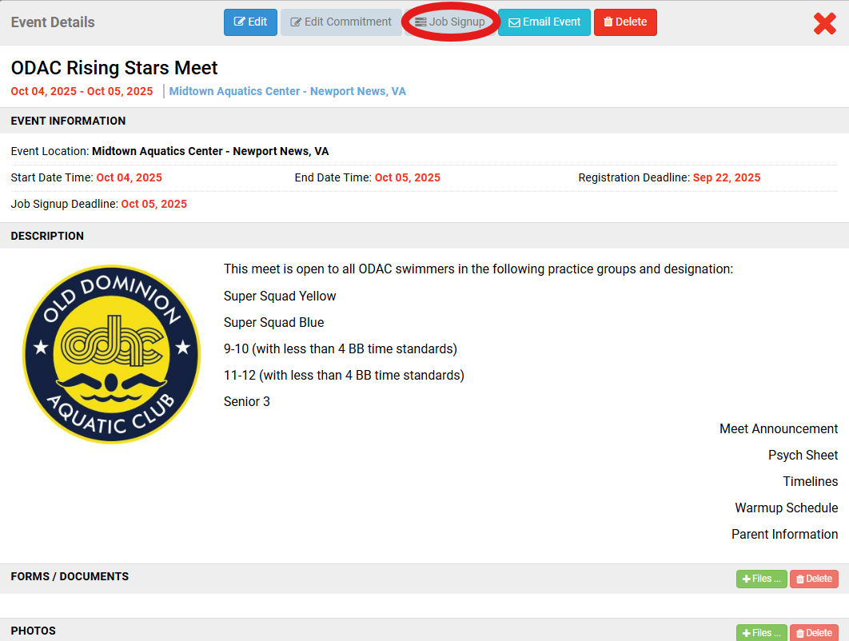

Volunteering for ODAC Hosted Meets
- Meets are a form of income for the team which subsidizes monthly dues.
- It’s very easy to get your family volunteer points in. The jobs are not hard and you can still watch your swimmer swim. While you are volunteering, you can still socialize and make friends with other swim parents.
- Signups are released approximately 2 weeks prior to the meet. Once slots are full, they are full.
- The Volunteer Coordinator will only enter points from the Job Signup.
**Bonus**: Benefits to becoming an official = best seat in the house, you are allowed on deck when working, you have access to the hospitality room (free food & drinks!) which is only for coaches and officials, you’ll learn more about swimming, and meet new friends. No swimming experience is required.

Recommended Swimming Apps

Meet Mobile App
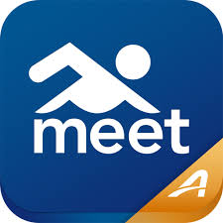
- Download this app for heat and lane assignments as well as meet results. This is used by most clubs in lieu of heat sheets.
- You can ‘favorite’ your child. Once your child finishes swimming, a notification will appear alerting you to their new time. Some meets have internet issues and times will not appear immediately. It may take minutes or hours for times to appear.
- Meet Results may not be correct when they appear on your app. Times are not final until scorers finish reviewing the event. Please be patient.
- There is a small yearly fee to use this app.

  - Sports Engine App
  - 
  - Download this app to view your child’s times and compare them to standards.
  - You can also view your balance, swim meets, and attendance (Practice History).
  - This app is free.
Once you have downloaded the application, you will be required to log in using the same login and password as ODAC’s website at www.swimodac.com.

Understanding USA Swimming Time Standards
  - Motivation. Progress. Performance. Perspective.
  - What Are Time Standards?
  - Time standards are performance benchmarks developed by USA Swimming to help swimmers:
- Set meaningful goals
- Track personal progress
- Earn invitations to championship-level meets
  - - Measure development across strokes and distances

USA Swimming time standards defined
- ​AAAA – This standard means your swimmer is ranked in the top 2% of swimmers in their age group, their same-sex, in that stroke and distance.
- AAA - This standard means your swimmer is ranked in the top 6% of swimmers in their age group, their same-sex, in that stroke and distance.
- AA - This standard means your swimmer is ranked in the top 8% of swimmers in their age group, their same-sex, in that stroke and distance.
- A - This standard means your swimmer is ranked in the top 15% of swimmers in their age group, their same-sex, in that stroke and distance.
- BB - This standard means your swimmer is ranked in the top 35% of swimmers in their age group, their same-sex, in that stroke and distance
- B - This standard means your swimmer is ranked in the top 55% of swimmers in their age group, their same-sex, in that stroke and distance.
- C - This standard is for all swimmers with times below the "B" standard. Everything from 0.00 up to the "B" standard is a "C" time.
  - 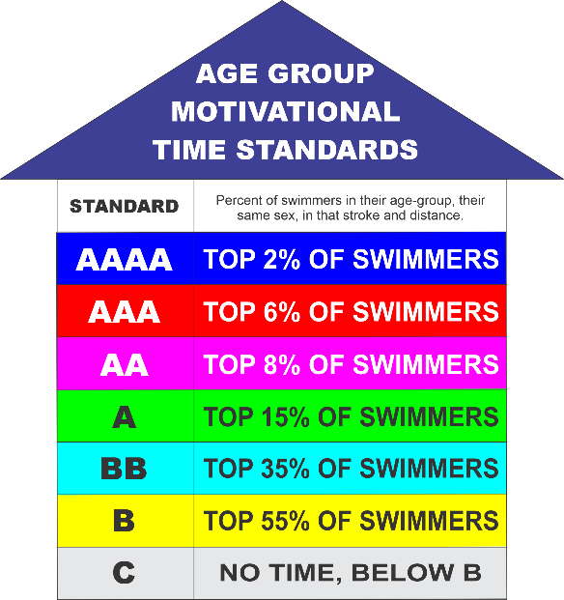
  - These standards are based on nationwide performance data and are updated every four years. Every swimmer in the U.S. who legally completes a race at a sanctioned meet is included in the national database.
  - Time Standard Levels
  - 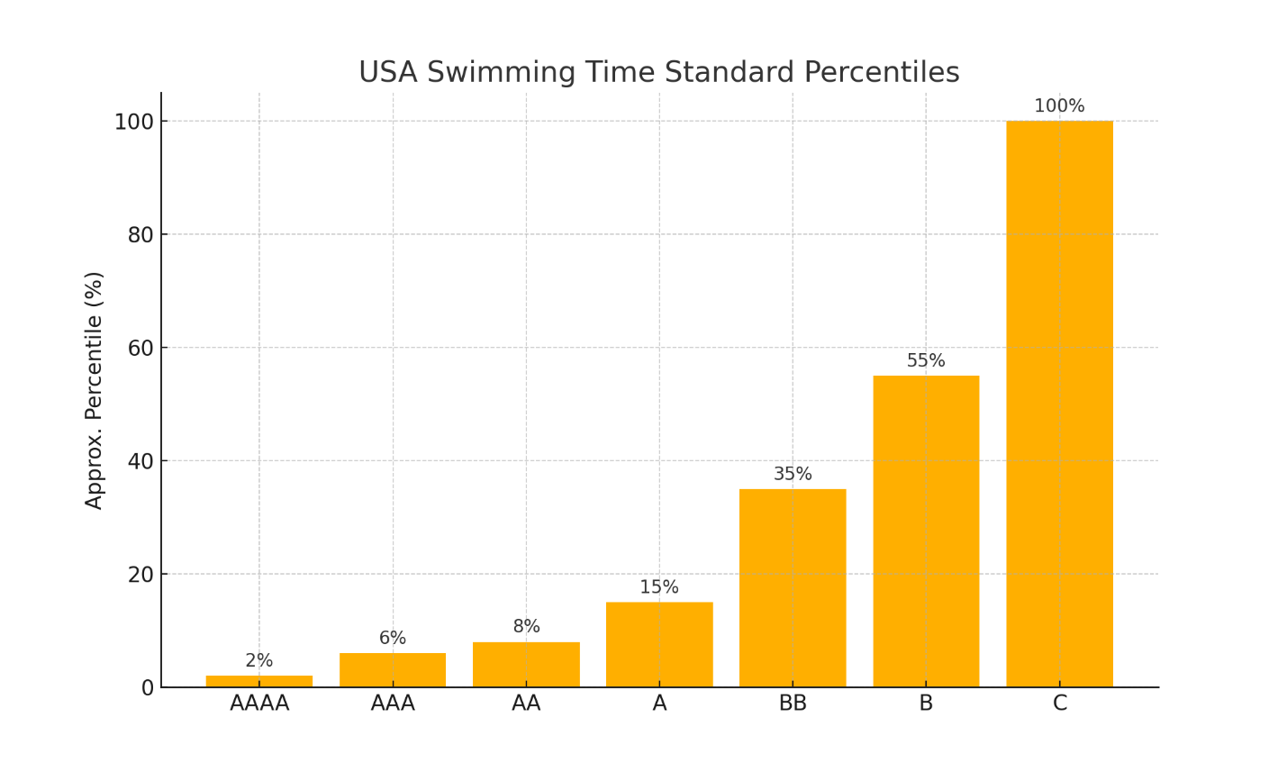
  - Fun Fact: A “BB” time means your swimmer is in the top third of their age group nationally!

  - Why Time Standards Matter at ODAC
  - They Motivate Without Pressure: These standards give swimmers clear, achievable goals. But ODAC emphasizes progress over perfection.
  - They may define Championship Eligibility: ODAC uses time standards to determine who qualifies for: In season meet opportunities for specific practice or age groups, Age Group Championships (AGC), Senior Champs (SC), NCSA Juniors, Futures, Winter Juniors, etc.
They Support Proper Group Placement & Meet Entry: Coaches may use standards to guide training groups or event selection.

  - Real Talk: Standards Are Guidelines — Not Labels
  - - It’s totally normal for a swimmer to be “A” in backstroke but “C” in breaststroke.
  - - Athletes mature at different rates. A 10-year-old with “B” times may become a standout in high school.
  - - Specialization is not recommended until full physical development. ODAC promotes all strokes and distances for a reason.

  - Coach's Advice for Parents
  - - Focus on consistent practice, great technique, and healthy habits.
  - - Time standards should inspire — not create stress.
  - - Never compare your swimmer to others. Progress is personal.

  - Where to Find Time Standards
  - You can also look up your swimmer’s official times and compare them at:
  - ▶️ USA Swimming’s SWIMS Database: https://www.usaswimming.org/times
  - ▶️ ODAC Time Standards Page on swimodac.com: http://www.swimodac.com

ODAC Communication & Support Guide
At ODAC, clear communication keeps our team running smoothly. This guide outlines where to find key information and who to contact when questions arise.
Where to Find Information
- Practice & Meet Schedules: www.swimodac.com → Team Information tab
- Emails: Check inbox for regular ODAC updates and reminders
- Social Media: @OldDominionAquaticClub (Facebook) | @swimodac (Instagram)
- Billing, Registration & Meet Info: SportsEngine platform
Who to Contact
- General Club Questions: ODAC Office (Mon–Fri, 9:00 AM–2:00 PM)
Swimodac@msn.com or 757-471-1828
- Billing / Payments: Valerie Pyron
vpyron@cox.net
- Volunteering / Points: Ashley Lawrence & Elizabeth Gibson-Palmer
ashley.deutsch@gmail.com or egibson1228@gmail.com
- BINGO: Alison McNabb:
Alison.McNabb@vbschools.com
- Officials & Certifications: Lauren Matthaey
lauren.matthaey@gmail.com
- Coaching Concerns: Steve Bialorucki, Head Coach
Stevebialorucki@swimodac.com
- Practice-Specific Questions: Your child’s assigned coach (via email only)
- Serious Concerns / Governance: ODAC Board of Directors
Mike McNabb (President) mmcnabb@abnb.org

ODAC Communication Expectations
- Email is preferred; allow 24–48 business hours for a reply
- Do not approach coaches on deck during practices
- Read team emails and check the website before asking questions
- Use social media for team culture—official info comes via email and website

ODAC Frequently Asked Questions (FAQ)
  - This guide answers common questions from new ODAC families.
  - Do we have to attend every swim meet?
  - Not every meet—but most. ODAC swimmers are expected to compete regularly (1–2 meets per month). Championship meet attendance is highly encouraged.
  - What should we bring to a swim meet?
  - Team suit, ODAC cap, backup goggles, towels, water, snacks, heat sheet, and warm clothes. See 'Swim Meets 101' for details.
  - How early should we arrive at meets?
  - Be on deck 15–20 minutes before warmups begin. Late arrivals may miss events.
  - Do we have to buy the ODAC suit and cap?
  - Yes. All ODAC swimmers must wear the official team suit and cap at competitions. Parents purchase suits directly from TYR, but caps can be purchased through the ODAC office.
  - How do I sign up for a swim meet?
  - Declare attendance via SportsEngine. Coaches assign events. See the Meet Sign-Up section for full steps.
  - What does it mean if my swimmer is “DQ’d”?
  - It means they were disqualified for a rules violation. It's a normal learning step. Coaches will explain and correct.
  - Can I talk to the coach during practice or at a meet?
  - No. Please email your coach to schedule a time to talk. Do not approach them on deck unless invited.
  - How does ODAC communicate with families?
  - Email is our primary method. Also check www.swimodac.com and follow us on Facebook and Instagram.
  - What if I have a billing question?
  - Email Valerie Pyron, ODAC's billing administrator.
  - I called the office but no one answered. Now what?
  - Office hours are Mon–Fri, 9:00 AM to 2:00 PM. Leave a voicemail or send an email for a response within a few hours.
  - What if I still have questions?
  - Start with this booklet, then contact the appropriate person listed in 'Communication & Support.' If unsure, email the ODAC office.

